

NEWSLETTER OF THE KENT PHILATELIC SOCIETY
P.O. Box 1156, Grand Rapids, Michigan 49501-1156
Louis Morel, President and Editor 269-420-3128
KentPhilatelicSociety.com

K.P.S. Philatelist
Volume 70- No. 6 June 2026

KPS Club News
This month, we join many philatelic organizations by introducing the distribution of our newsletter, The KPS Philatelist, in digital form. You will receive the June issue in print form as well. It is the final printed issue that you will receive. Unless, of course, you have contacted the editor to specifically request that you continue to receive a printed copy by snail mail. It’s not too late to do so. Some members already have made that request.  You will receive the digital version from the Club’s mailbox, kps.stampclub@gmail.com. You can send comments and questions to that same email address.  This is a momentous year as the United States of America celebrates its 250th anniversary. American postage stamps have honored the men and women that shaped the American Revolution and led to the birth of a Republic. This spring, the USPS issued ten stamps highlighting objects from the Revolutionary Era and twenty-five more that depict the people who helped in the country's fight for independence. They include a Quaker who set aside his faith’s most sacred principle and picked up a musket. An enslaved man who infiltrated the British camp and helped win the war at Yorktown. A Polish military engineer who crossed an ocean to fight for a country that wasn’t his own. A woman who heard the words “all men are created equal” and walked into a courtroom to demand they | apply to her. Many others demonstrated great courage and sacrifice.  David Luke will share part of his collection that focuses on the country’s bicentennial at this month’s meeting. David also will address the postal celebration of the 250th anniversary and add some pertinent anecdotes. Note that the presentation will start at 6:45 PM followed by the auction.  The aforementioned Spring Bourse was held on May 9. Seventy-seven people participated on that Saturday. Nine of them were first-time visitors to a KPS Bourse. Our own Kevin McCombs won the 50-50 raffle.  A mini-bourse (two dealers), food and beverages will highlight the third annual Summer Stamp Social. It will take place on July 11 at the Byron Center Baptist Church. We are seeking a member to chair the organizing committee. This person will oversee the acquisition of the food and non-food items as well as the layout of tables. We will need volunteers to help set up and restore the event space. We will need volunteers at the registration desk to greet the visitors. We will need assistance with grilling and serving the food as well. Contact Bill Sobotka (616.531.3295) to add your name to the list.
The KPS Board will enhance our monthly auctions by holding a drawing for a FREE $10 certificate toward the winning purchases of one lucky member. You need to be present to participate in the drawing.

MONTHLY PROGRAM SCHEDULE
June 23, 2026: KPS CLUB MEETING  5:30 PM Board Meeting  6:00 PM Lot Viewing  6:45 PM Presentation and Floor Auction | July 28, 2026: KPS CLUB MEETING  5:30 PM Board Meeting  6:15 PM Lot Viewing  7:00 PM Bill’s Accumulation Auction
The Kent Philatelic Society meets on the 4th Tuesday of the month at the Byron Center Baptist Church, 7343 Byron Center Ave SW, Byron Center.

Members are invited to share their philatelic experiences in this space. Perhaps you made a special acquisition, or thrive on an uncommon collecting topic, or saw a remarkable exhibit. Share it with your fellow collectors. Contact the Editor with your stories.
Haym Salomon: Contributor to the Cause
This is the third in a series of four on the “Contributors to the Cause” stamp set (Scott # 1559-1562) issued for the 1976 United States Bicentennial. It seems appropriate to look at this set in light or our nation’s Sesquicentennial.

Haym Salomon was one of the most influential yet often overlooked financiers of the American Revolution, a man whose strategic mind and unwavering commitment helped keep the Continental Army alive during its most desperate moments. His story blends courage, diplomacy, and financial genius, revealing how a single individual can shape the fate of a nation.

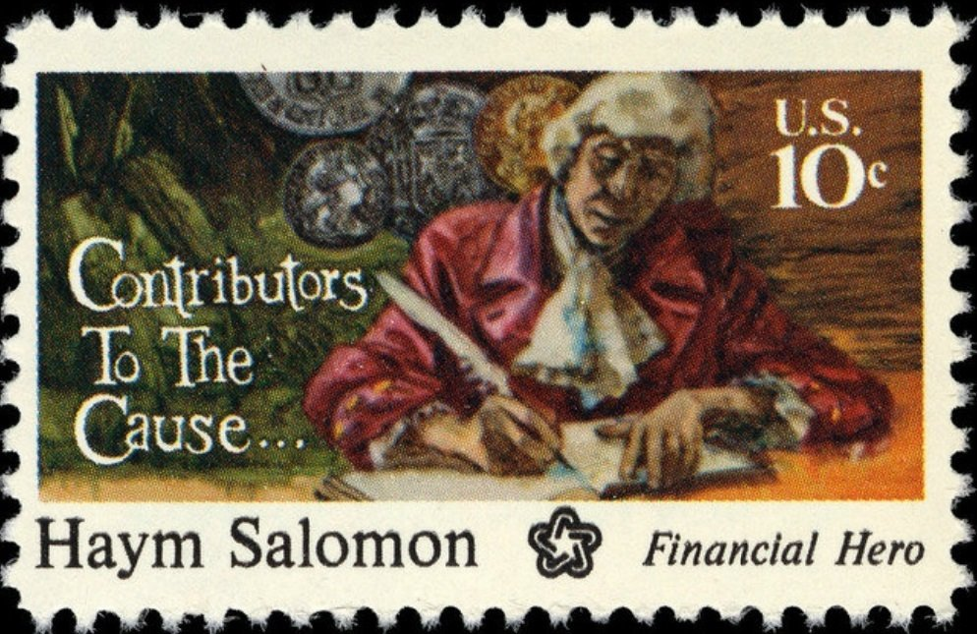
Salomon was born in 1740 in Poland, where he grew up in a Jewish community that faced frequent persecution. Seeking opportunity and safety, he traveled throughout Western Europe and learned a great deal about finance and other languages. He returned home to Poland in 1770, and spent some time in England before immigrating to the US and eventually settling in New York City in 1775. There, he quickly became a successful broker and merchant (Scott 1561 at left), respected for his linguistic skills and deep understanding of international finance. These talents would soon become invaluable to the revolutionary cause.

When the Revolutionary War erupted, Salomon sided firmly with the patriots and joined the Sons of Liberty. His support came at great personal risk. In 1776, British forces arrested him as a suspected spy. Though he avoided execution, he was imprisoned on a British ship for 18 months and released only after agreeing to serve as an interpreter for Hessian troops. Instead of aiding the British, Salomon used this position to help American prisoners escape and to encourage Hessian soldiers to desert. His covert work eventually led to a second arrest in 1778. He was sentenced to death, but was able to escape by bribing a jailer. He managed to escape to Philadelphia, where he rebuilt his broker business and intensified his support for the revolution. He soon became the agent to the French consul and the paymaster for the French forces in America.

It was in Philadelphia that Salomon made his most significant contributions. Working closely with Robert Morris, the Superintendent of Finance, he became the revolution’s chief broker. The Continental Congress was chronically short on funds, and inflation had rendered its currency nearly worthless. Salomon stepped in repeatedly, converting foreign loans into usable cash, extending personal credit, and often donating his own money outright. Without his efforts, the government would have struggled to pay soldiers, purchase supplies, or maintain diplomatic missions abroad.

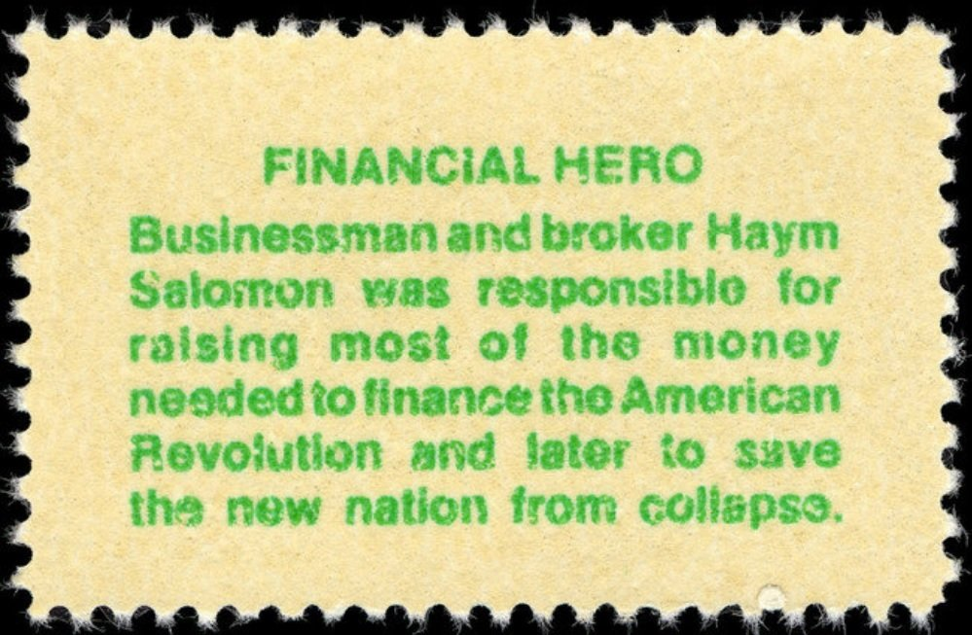
A description of the stamp’s design is printed in green on the reverse of each stamp in this set, beneath the gum. On the reverse of the Haym Salomon stamp is written “Businessman and broker, Haym Salomon was responsible for raising most of the money needed to finance the American Revolution and later to save the new nation from collapse.”

One of Salomon’s most famous acts came in 1781. General Washington had trapped British Lieutenant General Cornwallis at Yorktown. He was, however, unable to launch the battle because he and Congress didn’t have enough money to provide food, uniforms, or supplies for the troops to carry it out. Morris turned to Salomon who raised the necessary money within hours by selling bills of exchange, enabling Washington to lead the successful Battle of Yorktown. The resulting victory effectively ended the war, making Salomon’s role pivotal in securing American independence.

Salomon died in 1785 from tuberculosis that he had contracted in prison. He was deeply in debt, having sacrificed his fortune for the nation he helped create. His legacy, however, endures. Today he is honored as a symbol of patriotism, financial ingenuity, and the vital role Jewish Americans played in the founding of the United States.

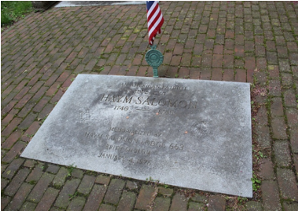
He is honored as part of the sculpture Triumvirate of the Patriots in Chicago. The triumvirate consists of the figures of Robert Morris, Haym Salomon, and George Washington. The grave site of Haym Salomon is located in the Mikveh Israel Cemetery in Philadelphia, Pennsylvania.

Dan Ondersma

